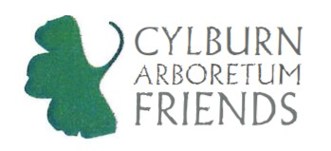
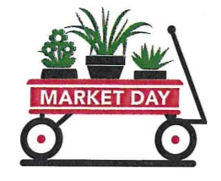
Market Day 2023:
May 12-13

FOR IMMEDIATE RELEASE

MEDIA CONTACT:
Brooke Fritz
brooke.fritz@cylburn.org

CYLBURN MARKET DAY EVENT
The 55th Annual Market Day will be held this year, rain or shine, on the grounds of
Cylburn Arboretum.
Dates and Times: Friday, May 12 (5-8pm) and Saturday, May 13 (8am-2pm)
Location: 4915 Greenspring Avenue, Baltimore MD 21209

BALTIMORE, May 11, 2023 – Join us for the 55th annual Cylburn Market Day!
Rain or shine, Vendors from across the region will join in the fun selling a wide variety of plants. Other gifts including pottery, jewelry, art and more will also be featured. Food and beverages will be on sale from participating food trucks on both days. Wagon rentals will be available and there will be lots of children’s activities!
In the evening on Friday, May 12 we have our Party on the Porch (5pm-8pm). This is a paid “preview” event ($50/ticket) for adults. Complementary wine and beer as well as music make for a festive and spirited event. This is for “plant-a-holics” who want first pick of Market Day merchandise!
Saturday, May 13 is our free, family friendly, public festival (8am-2pm). It is an opportunity for those interested in expanding their knowledge of plants, flowers, trees, herbs, and other flora that grow in Maryland’s soils to make purchases and talk to horticultural experts. But it is also fun – nursery booths brimming with flowers, artisan booths selling handmade goods, and a kids corner full of fun children’s activities.
We are so grateful to our sponsors: Lifebridge Health, North Hill Tree, Ziger | Snead and more. Thank you all for making this event possible!
For additional information, please visit our website at: https://cylburn.org/programs-events/market-day/

###

